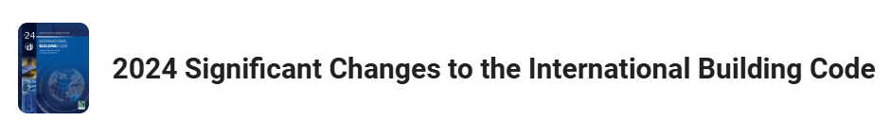

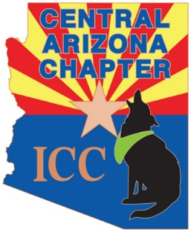

**November 2024**

**The AZBO Central Chapter hosted 83 students for an online training with ICC.**

**It was a full day training regarding the 2024 IRC significant changes.**

**Find a summary of changes** [**HERE**](chrome-extension://efaidnbmnnnibpcajpcglclefindmkaj/https:/www.nahb.org/-/media/NAHB/advocacy/docs/top-priorities/codes/code-adoption/signficant-code-changes-2024-irc.pdf?rev=a90577b5da8d4931b8beb20f21105df2&hash=D95B3F0AC6ADA32006389A67428A19A5)**.**

**ICC news Release found** [**HERE**](https://www.iccsafe.org/about/periodicals-and-newsroom/the-complete-set-of-2024-international-codes-is-now-available/)**.**